**Assignment -3**

Python Programming

| Assignment Date | 19 September 2022 |
| --- | --- |
| Student Name | Shambavi P |
| Maximum Marks | 2 Marks |

**Question-1:**

Download the dataset: Dataset

**Solution:**

https://drive.google.com/file/d/1xkynpL15pt6KT3YSlDimu4A5iRU9qYck/view

**Question-2:**

Image Augmentation.

**Solution:**

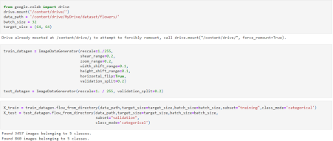**Question-3:**

Create Model

**Solution:**

**Question-4:**

**Add Layers (Convolution, MaxPooling, Flatten, Dense-(Hidden Layers),Output) Solution:**

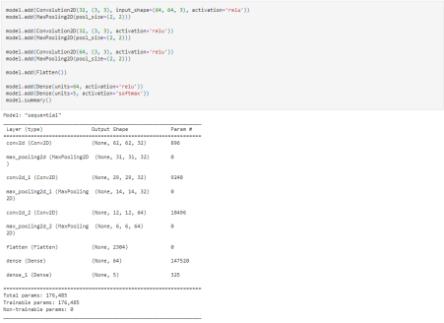

**Question-5:**

**Compile The Model**

**Solution:**

**Question-6:**

**Fit The Model**

**Solution:**

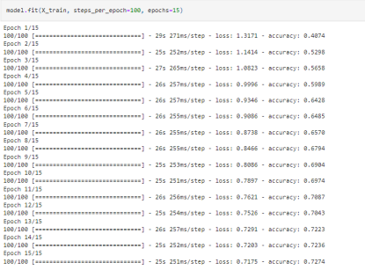**Question-7:**

**Save The Model**

**Solution:**



**Question-8:**

**Test The Model**

**Solution:**

